Rolling Ropner 10k
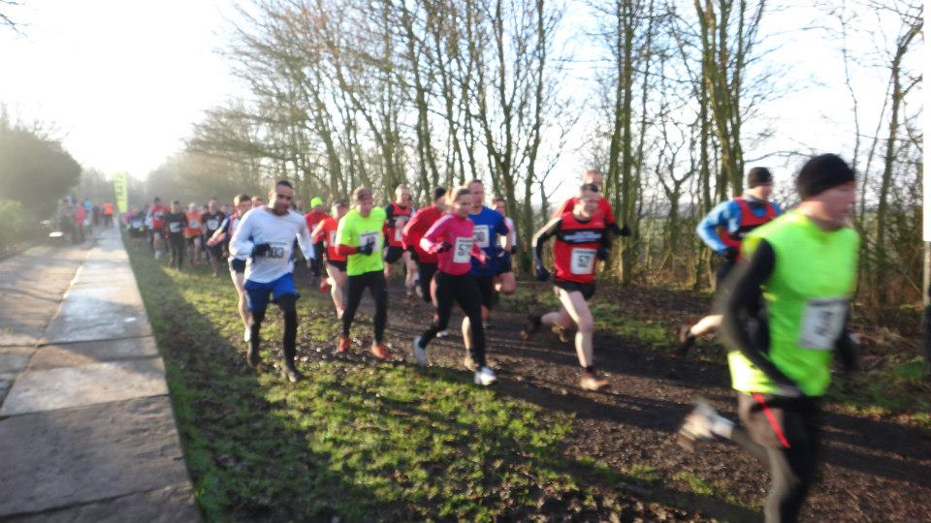
Sunday 22nd January 2017

Held under UKA Rules

Prizes:– First 3 Male & Females

Venue: Ropner Park, Hartburn Road, Stockton on Tees. TS18 4EP

Start Time: 10:00am. On the day entrees from 9:00-9:45am in the ‘Cafe’

Entry Fees: £8 UK Athletics affiliated runners £10 non-affiliated (unattached)

LIMITED ENTRY 300 Minimum age: 15 years on race day

Postal Entries to: Race Organiser, 20 Mond Crescent, Billingham, Stockton. TS23 1DL

Online entry: www.muddyroads.co.uk Goody Bags given to all those who enter.
Cheques made payable to: Muddy Roads, enquiries to events@muddyroads.co.uk (Race numbers to be collected on the day)

Beautiful scenic course which is all on tarmac, with a bandstand; fountain and a lake to run round (watch out for the swans, they sometimes like to join in)! This is a flat and fast course with some small inclines. Good for a PB, but still not an easy run!
_ _ _ _ _ _ _ _ _ _ _ _ _ _ _ _ _ _ _ _ _ _ _ _ _ _ _ _ _ _ _ _ _ _ _ _ _ _ _ _ _ _ _ _ _ _ _ _ _ _ _ _ _ _ _ _ _ _

Please enter me for the Ropner 10k on 22nd January 2017

SURNAME_______________________ FORENAME ________________________

DATE OF BIRTH__________________

AGE ON RACE DAY_________________ Sex: Male/Female (delete as applicable)

ADDRESS_______________________________________________________________________________________

_______________________________________________________________________________________

Post Code______________________________________________

MOB NO_____________________EMAIL_________________________________

RUNNING CLUB/TEAM NAME ____________________________Affiliated Yes/No.

AFFILIATION NUMBER ________________________

I declare I will be 15 years of age or over on the day of this event. I agree that the organisers shall not be liable for any injury, accident, loss or damage to myself or to anyone accompanying me in consequence of my participation in this event. I also declare that I am medically fit at the date of this application and that I will not participate in the event unless I am medically fit to do so. I will also obey all Marshall’s and organiser’s instructions. In the opinion of the organiser, the nature of the course makes this race unsuitable for wheelchair athletes. No dogs allowed.

SIGNATURE………………………………(parent/guardian if under 18) DATE……………………

