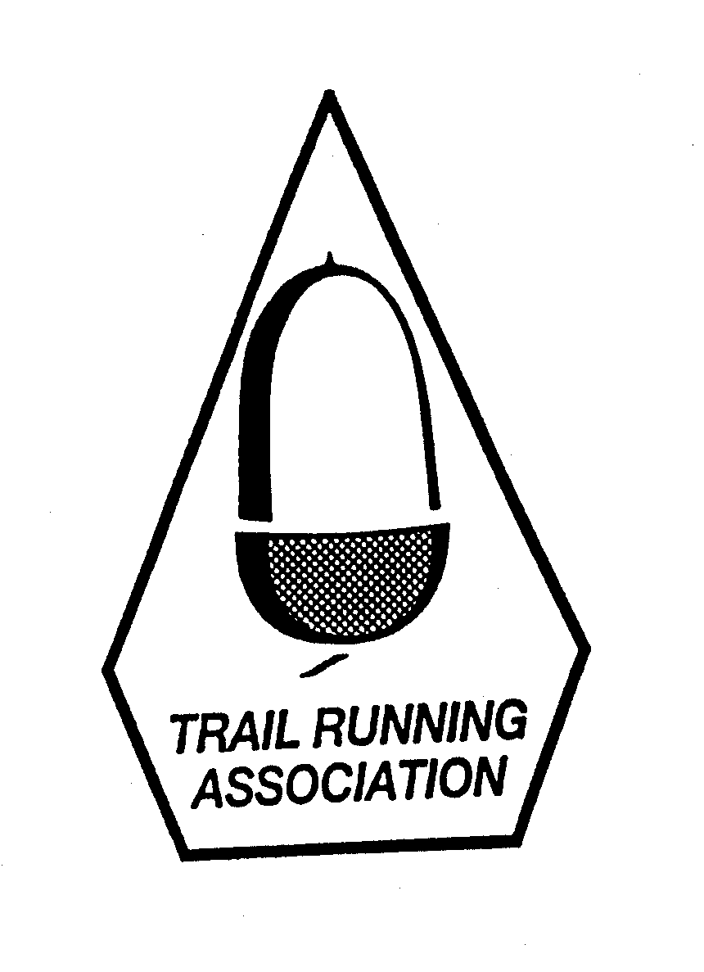

Let the Celebrations Roll

New Years Day
Town Moor Resolution Run
1st January 2018

Start: 11.00 / 10km / Short junior race at 10.45

In Aid of Water Aid & St Oswald’s Hospice
Entries accepted on race day from 09.30am till 10.50!

ENTRY: £10 DONATION FOR CHARITY
Pick number on race day at Exhibition Park café

This event is held under UKA rules and TRA permit
…………………………………………………………………………………….……………………………………………………………….

Full Name:_________________________________________________________________ Sex: □ M □ F Post Code:________________
Address:___________________________________________________________________ Aff Club:______________________________
Emergency Person & Contact: _______________________________________________________________________________________
Any medical condition that could affect you on race day?__________________________________________________________________
Entry: £10 is encouraged.
Make cheques payable to: All Terrain Events

Disclaimer: I accept all conditions of entry and that neither All Terrain Events nor any of the event sponsors shall be liable or responsible for any accident, damage or injury sustained by me or my property as a consequence of my participation in these events. Sorry, minimum entry age 16.

Signature:________________________________________ Date:____________

Enquiries: 0779 252 2865 / mrpsbhogal@gmail.com

